COMMUNITY FOCUS / A REPORT FOR NATURAL ENVIRONMENT
Overview

The environment – where we live, work and play. The people of southwest Missouri are blessed with a unique Ozarks tapestry of forests, rolling hills, limestone bluffs, springs, streams, and lakes which offer a remarkable range of recreational opportunities. Rapid population growth and urbanization provide exceptional economic development opportunities, but also bring intense pressure to bear on these irreplaceable natural resources. The expanded 2004 Environmental Report Card features sections on Water and Air Quality, Green-space, Energy and Water Usage, and Recycling. Trend lines will reveal over time our community’s degree of success in balancing prosperity with protecting our environmental legacy. As a community, we do not accept environmental degradation as the inevitable outcome of growth. Springfield and Greene County have a number of grass roots organizations that have earned the reputation of working together to promote environmental stewardship and to take proactive steps to meet the challenges of the region. Ozark Greenways, Watershed Committee of the Ozarks, the James River Basin Partnership and other volunteer, membership-based organizations work hand in hand with public agencies to promote a clean and healthy environment.

Conservation/environmental education is a priority for a number of these organizations and public agencies, as evidenced by the support of several facilities and programs devoted to raising awareness, offering environmentally responsible alternatives and celebrating good works. The Watershed Committee’s Watershed Center will be a state-of-the-art education/demonstration facility, making good use of the unique natural features on the Center’s site: a wetland, a losing stream, sinkholes, native plantings, a lake, a cave, karst outcroppings and a wealth of history, wild life and a LEED – certified Green Building. Wonders of Wildlife Zooquarium features conservation education and outreach programs. Springfield/Greene County Parks Department offers a full array of outdoor experiences and education through their Outdoor Initiatives Program. The Springfield Conservation Nature Center, owned/operated by the Missouri Department of Conservation offers a wide range of educational experiences, as does Dickerson Park Zoo. The Discovery Center of Springfield will have the First LEED – certified Green Building to be constructed in Springfield and will utilize both the process and the building in their environmental education activities.

Parks, Open Space & Greenways
Springfield and Greene County residents value parks, open space and greenways as evidenced by their being included in the first Vision 20/20 planning project, approval of the subsequent planning document (the first of the Vision 20/20 plan components to be approved) and, ultimately, approval of a sales tax to fund the Plan implementation. Because of the rapid rate of development in and around Springfield, there is a race to secure green space and include areas for parks, wildlife habitat and human recreational areas.

While this particular community value is a bit of a challenge to “quantify” because of the intrinsic contribution to the overall quality of life in our community, we have chosen to track the amount of park/green space available and the miles of trails and bike lanes as an indication of our progress.

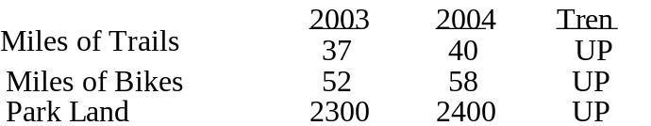

Springfield recently received recognition as one of 23 communities in the nation for efforts in becoming a bicycle friendly community.

Energy
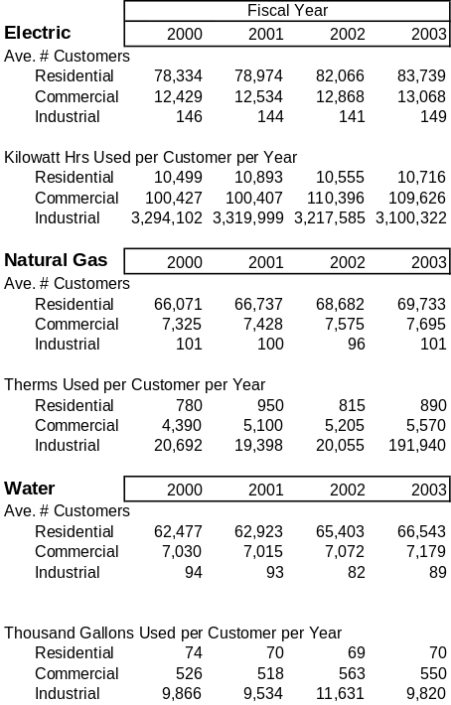

Air Quality
Springfield Air Quality Control monitors the ambient air for carbon monoxide, (CO), nitrogen dioxide, (NO₂), sulfur dioxide (SO₂), particulate matter (PM 2.5, 10) and ozone (O₃). While our air is cleaner than Environmental Protection Agency standards, two pollutants are of concern. Ozone and fine particles have concentrations closest to the unacceptable level. Continued development in the Springfield area may cause the pollutants to increase in the future.
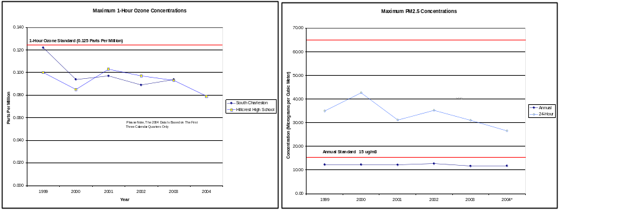

Particulate matter is a combination of fine solids such as dirt, soil, dust, pollens, molds, ashes, and soot; and aerosols that are formed in the atmosphere from gaseous combustion by-products such as volatile organic compounds, sulfur dioxide and nitrogen oxides.
Particulate pollution comes from diverse sources as factory and utility smokestacks, vehicle exhaust, wood burning, mining, construction activity, and agriculture.
Particles of special concern to the protection of lung health are those known as fine particles, less than 2.5 microns in diameter. Fine particles are easily inhaled deeply into the lungs were they can be absorbed into the bloodstream or remain embedded for long periods of time.
Ozone is formed by the action of sunlight on the carbon-based chemicals known as hydrocarbons, acting in combination with a group of air pollutants called oxides of nitrogen.
Hydrocarbons are emitted by motor vehicles, oil and chemical storage and handling facilities and a variety of commercial and industrial sources such as gas stations, dry cleaners and degreasing operations.
Oxides of nitrogen are a by-product of burning fuel in sources such as power plants, steel mills and other heavy industry and in motor vehicles.
Water Quality

Water is the environmental life blood of the Ozarks. Beyond quality of life considerations, water quality is an economic development issue as well. Significant degradation of water resources will impact every resident and their pocketbook. Citizen awareness has clearly increased due to enhanced press coverage and public dialogue. According to a Vision 20/20 Planning Survey conducted in 2003, “78% of this year’s survey respondents said that improving the water quality of area lakes and streams was ‘very important’.” Springfield’s drinking water supply is largely surface water (McDaniel, Fellow’s Lakes with Stockton Lake as a reserve). For many Greene County residents, groundwater serves as their drinking water source through private wells; therefore, monitoring and protecting both surface and ground water quantity and quality is conducted. Trend lines provide generally encouraging signals as to the effectiveness of community stewardship. Phosphorus discharge data at the Springfield Southwest Wastewater Treatment Plant reflects a recent facility upgrade and translates into improved water clarity and lower phosphorus content at Table Rock Lake (James River arm).

The City of Springfield and Greene County have taken a leadership role in the protection of the water quality of the local receiving bodies of water. Springfield is the first city in Missouri to have received an NPDES MS4 Storm Water Permit, which the News-Leader referred to as “an honor and a challenge” . Now in the third year of the permit, the City has posted reports for the first two years online at www.springfieldmogov.org/stormwater. Greene County is also in the third year of their Phase II Storm Water Permit.

A wide variety of activities are included in both the City’s and the County’s efforts, including stream and runoff sampling, illicit discharge prevention through enforcement and education, GIS mapping, review and revision of developers design standards and on-site management practices, Show-Me Yards & Neighborhoods (urban lawn care educational program), revised internal maintenance standards including street sweeping, covering of salt storage areas, and many other activities –some required by the permits and some performed on a proactive, voluntary basis. The City and County work with other agencies, organizations and business/industry in collaborative projects such as the Habitat for Humanity Low Impact Development, the Watershed Center, James River Basin Partnership’s storm drain stenciling project and others.

The City and County’s approach toward the Storm Water Permits over the last 3 years has been a more far reaching water quality program than you can find anywhere in the state -- evident in the annual reports.

In addition the beginning of the floodplain acquisition program in 1994 was ahead of its time and the program has been successful for 11 years.
The City’s floodplain acquisition program has made a significant impact. Funded by the Level Property Tax, Public Works has acquired over 100 flood prone properties – most containing residences – totaling approximately 100 acres of floodplain land, at a cost of over $9 million, along waterways and in sinkholes. The land has been reclaimed as green space for use as neighborhood open space or greenway trails. Most notable are the Galloway and South Creek Greenway Trails.

Areas of concern include: funding shortages to address developing problems including 1. Increasing demands nationally to meet storm water runoff provisions of the Clean Water Act. In the Midwest we often have the luxury of "seeing what's coming" regarding environmental policy by watching activities in places such as Seattle, Portland, Florida and Maryland. It is in the best interest of our citizens to stay ahead of these coming demands; and 2. Increasing need for maintenance and replacement of the City’s aging and deteriorating 600 miles of storm water infrastructure as well as addressing rapid growth pressures in the County.
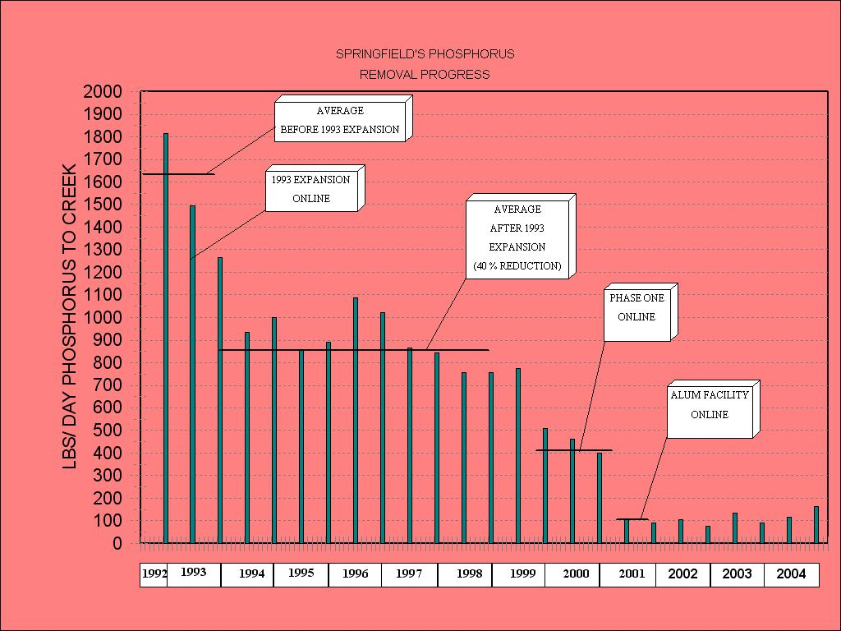
Phosphorus Reduction
Recognizing the large contribution to the nutrient loading in the James River and subsequently, in Table Rock Lake and Lake Taneycomo, and acknowledging the very large economic impact of those industries (fishing, tourism, and others) that are dependent on clean water in our region, the City of Springfield, has implemented phosphorus removal at the City’s Southwest Wastewater Treatment Plant that has reduced the phosphorus entering the James River from over 1600 pounds/day (pre-1993 expansion) to approximately 150 pounds/day (2004). This was completed two years ahead of the state-required deadline. In addition, the latest $24 million expansion to that plant (scheduled for completion in late summer, 2005) will also address nitrates – for which there are no state regulations in place or planned. The City’s Northwest Wastewater Treatment Plant is beginning a $22 million expansion, which will include phosphorus removal and nitrate removal. Neither of these activities are required for that plant.

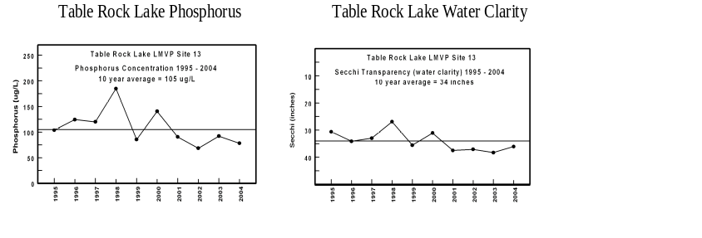
Rural vs. Urban Streams
Urban streams are generally less healthy than rural streams because of the effects of concentrated runoff and multiple pollution sources in urban areas (as shown in the graphs). Good diversity (many kinds of organisms living in the stream, including sensitive species) is a sign of a healthy stream. This diversity is measured by collecting and counting organisms, called macroinvertebrates, living in the gravel of the stream bottom. The degree of diversity is reflected in the “water quality index.” The higher the number, the better the health of the stream
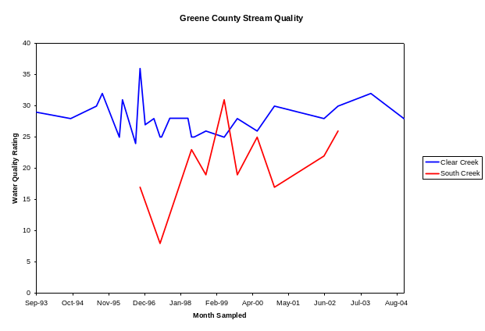

Water Well Testing
The Springfield-Greene County Health Department offers water testing to private well owners at no charge. On average nearly 40% of wells test unsafe annually. This figure can be misleading as this testing is not random and often times wells are tested due to problems related to odor, turbidity, or illness.

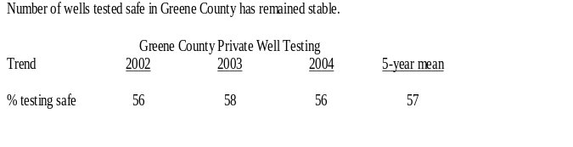

Solid Waste Management
Springfield/Greene County’s Integrated Solid Waste Management System (ISWMS), approved by voters in l99l and implemented by the Solid Waste Management Division of the City’s Public Works Department, includes the following components: Household Chemical Collection Center, Yardwaste Recycling Center, Recycling (Drop-off) Centers, Springfield Sanitary Landfill, Market Development Program, and Information and Education Program. Curbside recycling, also a part of the ISWMS is provided by private solid waste haulers. Springfield is one of only three communities in Missouri to offer citizens the full range of services for managing solid waste (trash) and the only community to include an award-winning Market Development Program. Public support for waste reduction and recycling efforts remains strong as is evidenced in the trend graph.

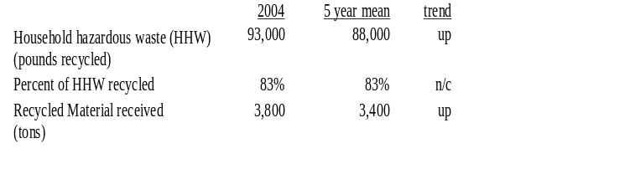

Springfield generates an estimated 1500 tons of trash per day, with only approximately 300 – 350 tons per day going into the Springfield Sanitary Landfill. While this is seen as favorable in that it extends the useful life of the Landfill, it also poses a paradox because funding for the ISWMS is primarily from revenues generated by the Springfield Sanitary Landfill tipping fees. (No tax money or general City revenue is included in funding for the ISWMS). Larger, national trash companies currently operate their own landfills outside of Springfield and utilize these facilities for the majority of the trash they collect – reducing the revenue available to fund the various services of the ISWMS. Since the beginning implementation of the ISWMS, the City has struggled with this dilemma and the continuous ebbs and flows of the funding level. At some point, a permanent, and stable source of funding will be needed in order to secure the sustainability of Springfield’s ISWMS.

Population Growth

Springfield and Greene County continue to be included in one of the most rapidly growing regions in the country. Growth brings with it all-encompassing challenges to existing resources and infrastructure. Unfortunately, in too many communities, the natural environment is a casualty of such rapid and sustained growth. Residents and leaders in our community refuse to accept environmental degradation as the inevitable result of growth. As a community, we struggle with the delicate balancing of growth and economic development and preservation and protection of the beautiful natural features that attract so many to make the Ozarks their home. We recognize the undeniable connection between a healthy environment and a healthy economy for our region as well as the undesirable consequences to human health if we fail to maintain our clean water and clean air.

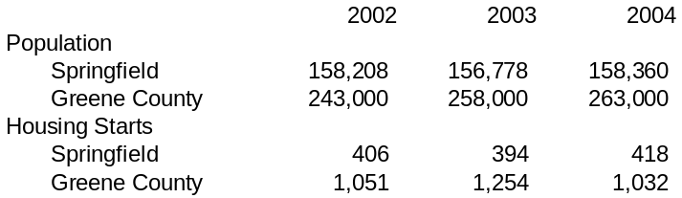

Water Quantity
Springfield/ Greene County is just beginning to recognize the possibility of water quantity challenges being in our future. Monitoring water quantity data is just beginning, but will be continued as we face another challenge of the rapid and steady growth of our region.

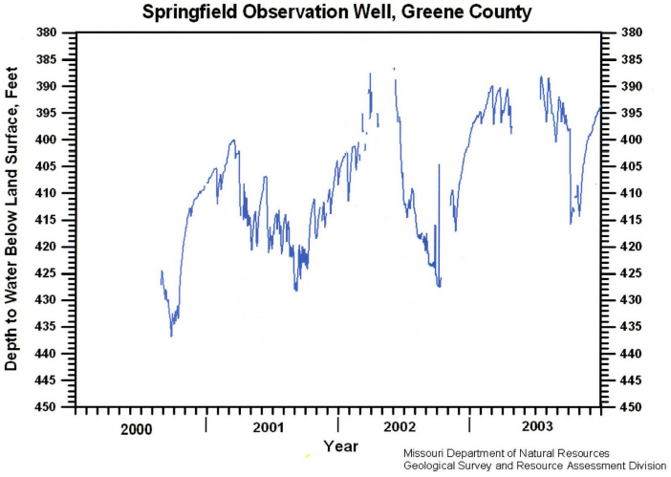

Contributors
What does all this mean? The data suggests that water quality is stabilizing but still at risk, air quality is improving, green-space is expanding, recycling is growing, and that energy and water use is relatively flat despite increased number of users. Only by reporting trends over a longer period will citizens be able to determine if growth is impairing our natural resources.

Additional source and support data are attached.
Todd Parnell, Co-Chair
Barbara Lucks, City of Springfield Public Works
Dept., Co-Chair
Matt McFail – The Signature Bank
Terry Whaley – Ozark Greenways, Inc.
Ron Carey – City of Springfield, Planning Dept.
Bob Schaefer, Harry Price, Ed Malter, Todd Wagner,
David Hutchison, Carrie Lamb – City of Springfield,
Public Works Dept.
Clay Goddard, Karl Barke – Springfield/Greene
County Health Dept.
Cara Shaefer, City Utilities of Springfield

